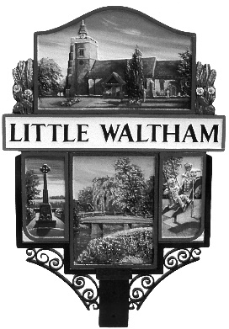

Little Waltham Parish Council

Grant application form 2020

Question 1: Information about you or your organisation
1a: Your organisations name and address
This should be as provided in your constitution or set of rules

1b. Main contact name and phone number
This must be somebody who we can contact to talk about the application

1c. Contact’s Position
For example, Treasurer or Secretary

1d. Address for correspondence if different from above

1e. Please confirm the type of organisation (i.e. Charity, unincorporated association etc.) If your organisation is a registered charity, please give a registration number

1f. What are the main activities of your organisation

Question 2: General information

2a: Please give the reason as to why your organisation has applied for money from the Parish Council and details of how the money will be used. If it is for a specific project please provide an intended timetable and outcome for the project.

Question 2b: Please explain how the provision of money to your organisation will be of benefit to the community of the Parish of Little Waltham?

Question 3: Finance and Other Funding

3a: Please indicate what your organisation has done to obtain funding from other sources.
Include letters of completed applications from other bodies, sponsorship from local businesses etc.

3b: Please indicate what fund raising events your organisation has carried out or plans to carry out to raise funds for this project.

3c: Tell us how much money you need for your project and give a break down of what the money is for. Where possible please include at least two estimates for work or equipment.

Item or Activity……………………………………………………………. | Total Cost ….
Total

3d: How much are you requesting from the Parish Council

£

Please include with this application:

- Any supporting evidence for the need of the project
- Evidence of secured funding or applications for other funding
- Estimates for work/equipment were appropriate

Declaration

I confirm that I am authorised to sign this declaration. The information in it is correct to the best of my knowledge. If this application is successful the grant will only be used for the purposes specified in this application.

Signed: …………………………………………………….

Date: ……………………………………………………….

Position (if applicable)……………………………………….

Return Completed forms to: Suzanne Walker, Clerk to the Parish Council,
Either via email – clerk@littlewaltham.org.uk or by post
7 Mallard Close, Great Notley, Braintree, Essex CM77 7YD

